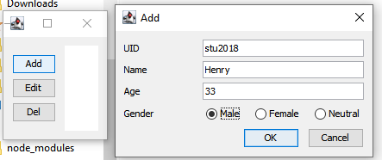

Fig 1, Original list, Add dialog

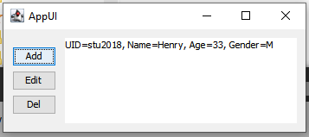

Fig 2, After add.

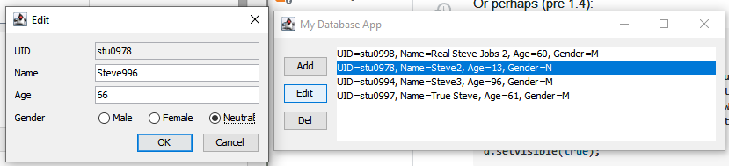

Fig 3, Before edit

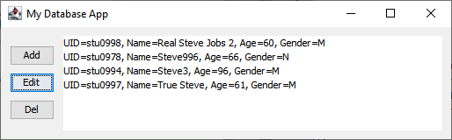

Fig 4, After edit

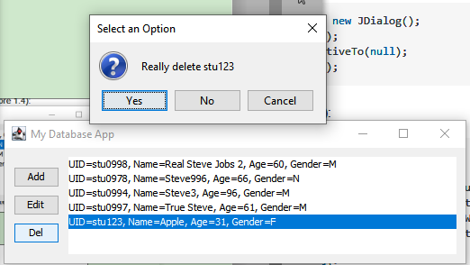

Fig 5, Before delete

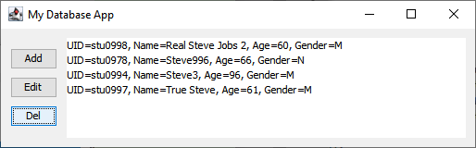

Fig 6, After delete